YANGCUN BRIDGE

BRIDGE

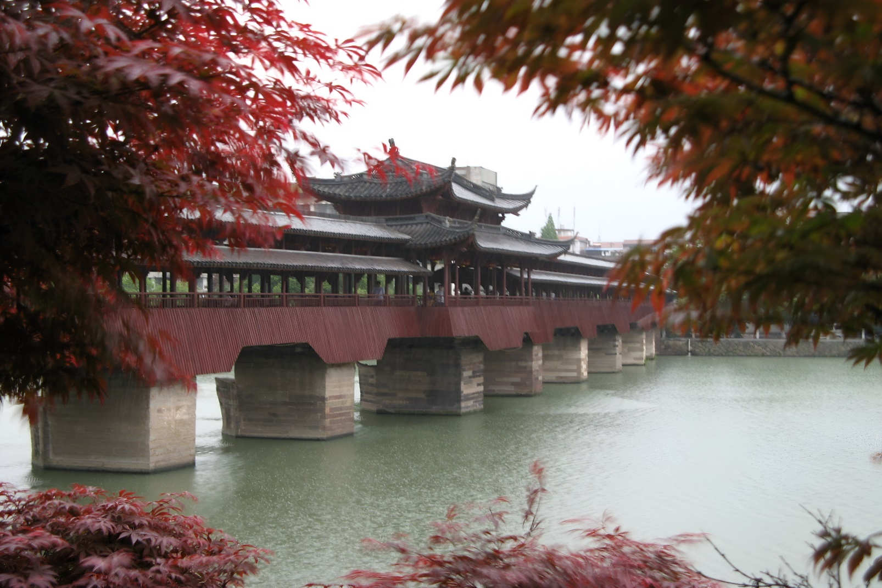

The Yangcun Bridge, a magnificent engineering feat nestled within the landscapes of China, spans gracefully across the mighty Yangtze River, symbolizing the fusion of human ingenuity with the natural world. As one of the key components of the country's expansive transportation network, this bridge serves as a vital link between regions, connecting bustling urban centers with rural hinterlands. With a length of approximately 11.7 kilometers (7.3 miles), the Yangcun Bridge stands as a testament to China's commitment to infrastructure development and technological advancement.

Constructed using state-of-the-art engineering techniques and materials, the Yangcun Bridge is a marvel of modern design and construction. Its sleek, contemporary profile is characterized by a series of reinforced concrete pillars and beams that seamlessly traverse the river's breadth, supported by sturdy foundations anchored deep within the riverbed. The bridge's expansive deck provides ample space for vehicular traffic, accommodating the flow of cars, trucks, and buses that traverse its length each day.

The bridge's elegant silhouette serves as a stark contrast to the natural beauty that surrounds it, a testament to humanity's ability to shape and transform the environment in which we live. Yet, despite its man-made origins, the Yangcun Bridge harmonizes effortlessly with its surroundings, blending seamlessly into the landscape like a natural extension of the river itself.